Documentation - Brandon Vu

Outline
NutriLog is a web-based calorie tracking application that allows users to log meals, automatically estimate calories using an external nutrition API, and review their intake over time. Users authenticate via a secure login system before accessing their personal dashboard. Once logged in, users can add meals by entering a food name and date, fetch estimated calorie values, edit existing entries, delete meals, and search previously logged meals.
The application is designed to be simple and lightweight while demonstrating core web application concepts including authentication, database integration, server-side rendering, API consumption, and CRUD functionality. NutriLog stores all user and meal data in a MySQL database and presents summaries such as daily and weekly calorie totals to help users understand their eating habits over time.
Architecture
NutriLog follows a traditional three-tier architecture. The application tier is built using Node.js and Express, handling routing, authentication, API requests, and business logic. Server-rendered views are created using EJS templates. The data tier uses MySQL, accessed via the mysql2 library, to persist users and meals. An external Edamam Food Database API is used to estimate calorie values. The application runs on port 8000 and uses environment variables for configuration.
Data Model
The data model consists of two main entities: users and meals. The users table stores authentication details, while the meals table stores meal entries associated with users via a foreign key. Each meal includes a name, calorie value, date, and creation timestamp. Passwords are securely stored using bcrypt hashes rather than plaintext. This structure supports user-specific data isolation and efficient querying for summaries and searches.

User Functionality
Users begin by accessing the login page, where they must authenticate before accessing any application features. The system supports a predefined login (username: gold, password: smiths) as required by the assignment, as well as newly registered users.
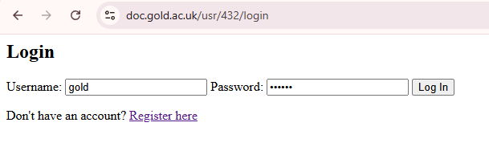
After successful login, users are redirected to the main meal dashboard. This page displays a personalised welcome message, a daily calorie summary, and a weekly calorie summary calculated from stored meal data.
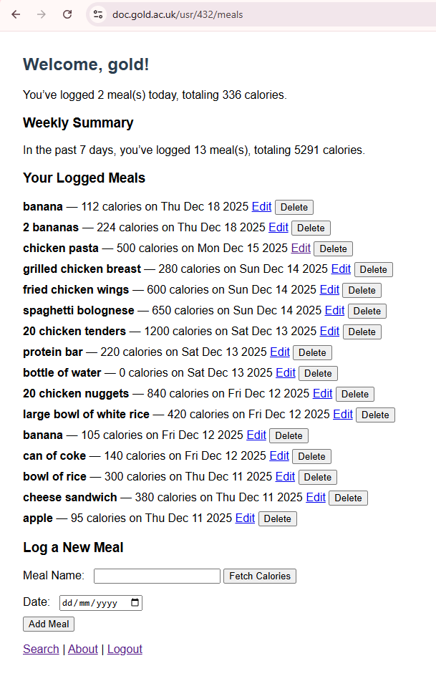
The dashboard also lists all previously logged meals, including the meal name, calorie value, and date. Each entry includes options to edit or delete the meal. When logging a new meal, users can enter a food name and request an automatic calorie estimate using the Edamam Food Database API. The estimated calorie value is displayed before the meal is saved, allowing the user to review the result.
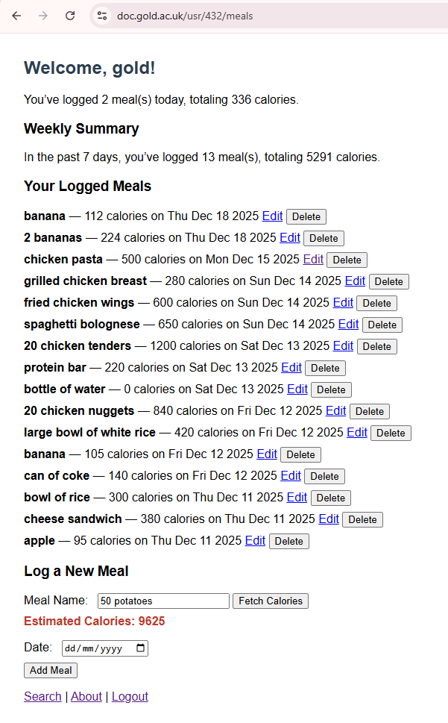

Users can edit previously logged meals via a dedicated edit page. This allows correction of meal names, calorie values, or dates.
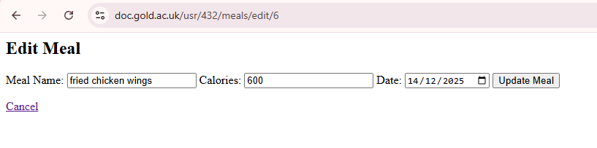
Advanced Techniques
NutriLog integrates an external REST API (Edamam Food Database API) to automatically estimate calories based on free-text food input. This demonstrates asynchronous API handling, error management, and client–server interaction. Due to the API’s limited rate allowance (approximately 5 requests per minute on the free tier), the application avoids excessive automatic calls and instead requires the user to explicitly click a “Fetch Calories” button.
Passwords are hashed using bcrypt before storage, providing industry-standard security. Session-based authentication ensures protected routes are inaccessible without login. Environment variables are used for sensitive configuration such as database credentials and API keys.

AI Declaration
AI tools such as co-pilot (built into VSCode) were used during the development of this assignment to assist with debugging, refining application logic, and improving code structure. AI was also used to help draft and refine documentation content. All code was reviewed, tested, and adapted by myself to ensure correctness and alignment with the assignment requirements.

